Methodology

We are planning to collect Micro Emotion data basically in two methods

1.Normal Video Capturing Using Slow Motion Enabled camera

2.Image capturing by Thermal Imaging Camera

**1.Normal Video Capturing Using Slow Motion Enabled camera**

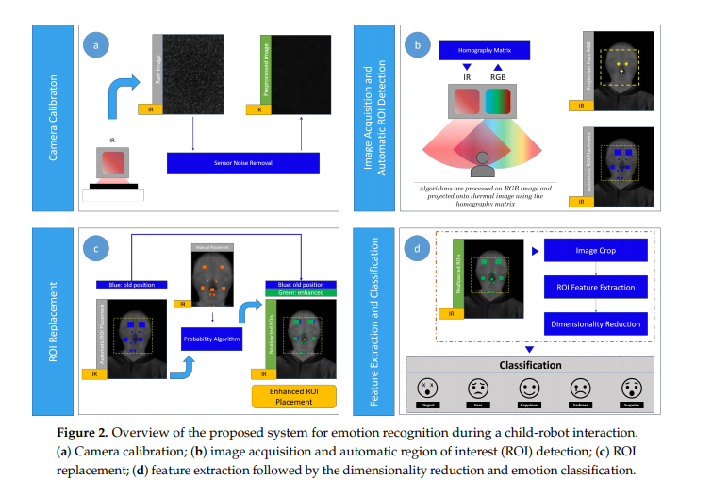Contact-Free Emotion Recognitionshows the proposed contact-free system for emotion recognition, which is composed of the following four steps: (a) camera calibration; (b) image acquisition and automatic ROI detection; (c) ROI replacement; (d) feature extraction followed by the dimensionality reduction and emotion classification. Figure 2a shows a first stage to calibrate the camera system by obtaining a homography matrix to map the pixels of the visual camera image into the thermal camera image, considering the relative fixed position between the two cameras. Also, another process is performed to obtain a frame that contains intrinsic noise of the infrared sensor, which is latter used in a second stage (Figure 2b) to remove the sensor noise (inherent to the camera) over the current thermal image captured. In this second stage, the image acquisition process is carried out taking synchronous images from both visual and infrared cameras, which are pre-processed to enhance the automatic facial ROIs detection by applying the Viola-Jones algorithm on the visual image. Then, the ROIs placed on the visual image are projected into the thermal image using the homography matrix. As a third stage, manual annotations by a trained expert over a reference frame are used to accurately relocate the ROIs by applying our approach based on errors of probability, such as shown in Figure 2c. Afterwards, feature vectors related to thermal variations are computed on the detected ROIs, and after reduced by applying PCA for dimensionality reduction for five emotion recognition in a last stage by LDA. More details about the proposed recognition system are given in the next subsections.

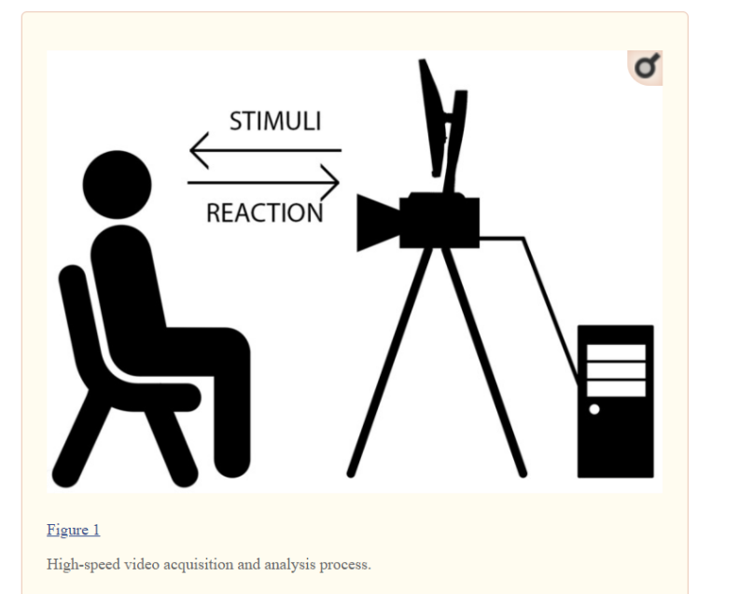

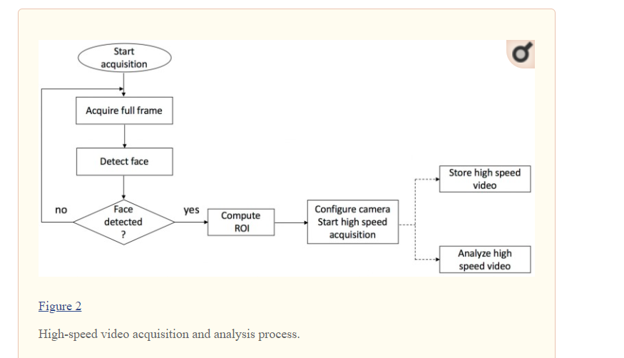The system starts to acquire images at full frame (2048 × 1088) using a 30 fps. The image processing host computer automatically detects the user’s face using a publicly available face detection library [[22](https://www.ncbi.nlm.nih.gov/pmc/articles/PMC5751645/#B22-sensors-17-02913)]. After the face is detected, a region of interest is automatically established such that it will include the detected face and a significant safety area around this face (the width and height of the ROI are 75% larger than the dimensions of the detected face). The camera is configured to use a ROI-based image acquisition method using the detected ROI which significantly reduces the data amount to be transferred via USB and stored in the computer’s memory, thus allowing high-speed video capture (more than 110 fps). The actual frame rate depends not only on the data amount, but also on the exposure time, which is not influenced by the ROI size. The flowchart of this process is depicted in [Figure 2](https://www.ncbi.nlm.nih.gov/pmc/articles/PMC5751645/figure/sensors-17-02913-f002/).

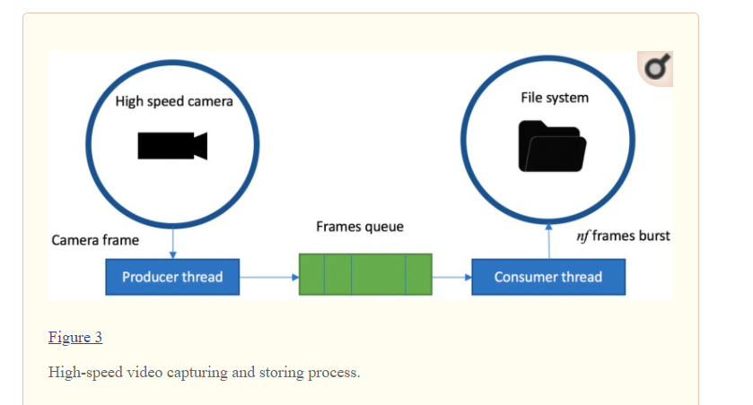

**2. Image capturing by Thermal Imaging Camera**

**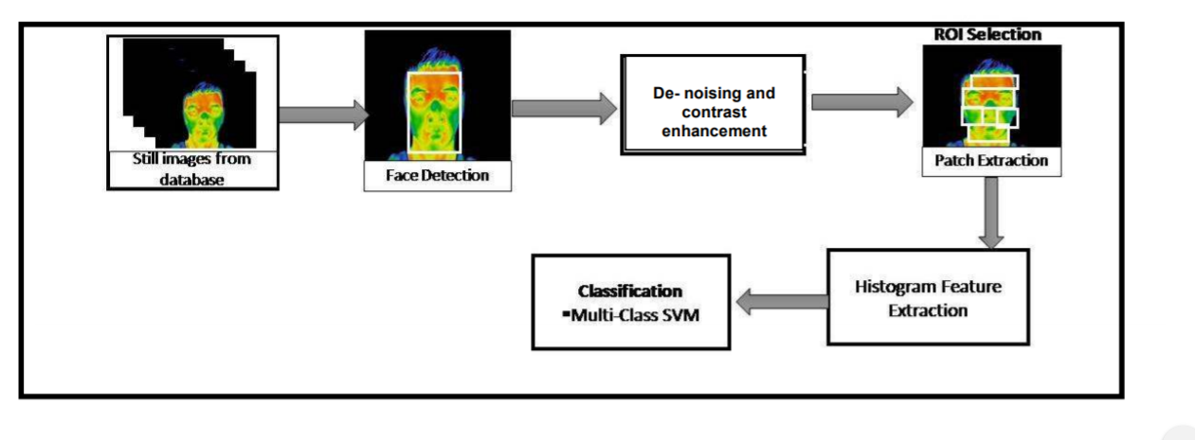**The overall procedure incorporated in this work starts with face detection from the images taken from the KTFE Database,, denoising and enhancement of facial images, selection of the region of interest (ROI) which includes facial patches extraction, histogram feature extraction and finally classification.

**2.1 Face Detection -** Viola Jones technique

**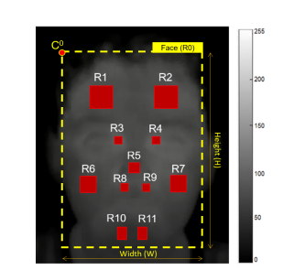**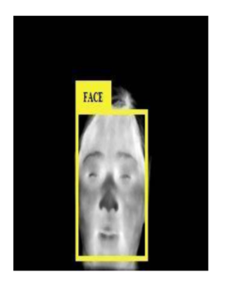Face detection is one of the most important step for localizing and extracting face region. The face knowledge is the most important portion for the analysis of emotions. The thermal images here are considered as color images and based on the consideration Viola-Jones algorithm is chosen in this work for thermal face detection. Viola Jones technique basically incorporates three steps which are integral image formation for feature computation, Adaboost technique which is used for feature selection and finally an attentional cascade formation for efficient computational resource allocation . All these steps combined together make the Viola Jones technique highly efficient for face detection. The detected face is then de-noised and enhanced which is described in the following section.

**2.2 De-noising and Contrast Adjustment:**

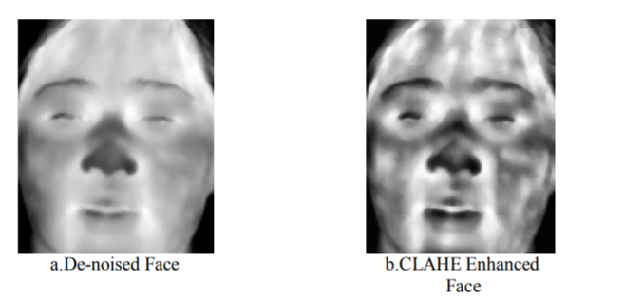Filtering is one of the most important steps for de-noising, enhancement, smoothing and template matching of images. The facial thermal images are de-noised initially by passing them through a median filter. Median filter considers each pixel of the image and replace its value with the median of the neighbouring pixels. Median filters are robust as well as good at removing noise while preserving sharp edges. The filtered image is enhanced by using Contrast Limited Adaptive Histogram Equalization (CLAHE) [7]. The CLAHE enhancement partitions an image into contextual regions and performs histogram equalization on each of the regions thus balancing the used gray values distributions. Thus in this process it makes the concealed features of the image properly visible. Thus the whole procedure consists of noise reduction while maintaining the high spatial content of the image by implementing the combination of median filtering, CLAHE and also edge sharpening.

2.3 ROI Selection:

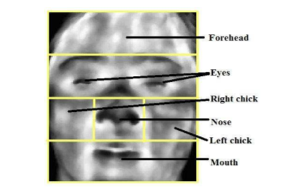The de-noised image face region is divided into six facial patches i.e. forehead, eyes, right cheek, left cheek, nose and mouth. Figure 4 shows the extracted facial patches from the total face. The facial patches have been extracted using the ratio based technique where the face region is segmented into the six segments based on some specific ratio considering the nose tip as the centre point of the face. Starting from the top first the forehead is segmented out, then the eyes, followed by the nose and cheek region and finally the mouth portion. The histogram features are further extracted from each of these patches and are fed to the classifier for further classification.

**2.4 Feature Extraction:**

The image features are the main representation of the image. It helps in the proper interpretation of the image. Features may be of many kinds like corners, edges, lines etc. The process of feature extraction helps in formation of a set of feature vectors from detected features also called descriptors. Thus choice and extraction of proper features are helpful for the appropriate analysis of the images. From thermal imaging perspective feature extraction can be thought of as the procedure to convert the images into unique and distinct form to compare with the reference. Histogram features are used as the classifying features for analysis of the individual's emotions.

**2.5 Classification:**

The classification of emotions based on the feature vectors is performed using the multiclass SVM [9]. SVM is mainly a binary classifier that categorises both linearly as well as non-linearly separable data .For linearly separated two class data, classification is achieved by constructing a hyper plane to separate the data by maximizing the separation margin.

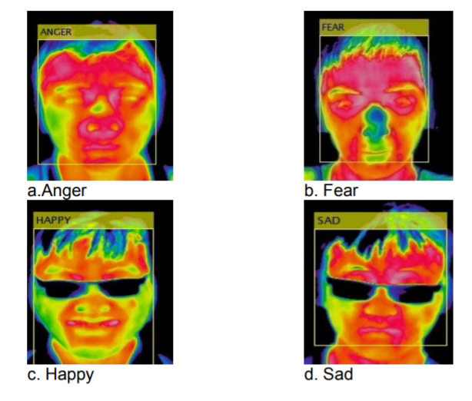As follow we hope to classify micro emotions using Support Vector machine algorithms

**Reference:**

[1] S. Wang, P. Shen, and Z. Liu, “Facial Expression Recognition from Infrared Thermal Images Using Temperature Difference by Voting,” IEEE 2nd International Conference on Cloud Computing and Intelligent Systems, pp. 94-98, 2012.

[2] Shan He, Shangfei Wang, Wuwei Lan and Huan Fu Qiang Ji, “Facial Expression Recognition using Deep Boltzmann Machine from Thermal,” Humaine Association Conference on Affective Computing and Intelligent Interaction, pp. 239–244, 2013.

[3] M. M. Khan, M. Ingleby and R. D. Ward, “Automated Facial Expression Classification and Affect Interpretation Using Infrared Measurement of Facial Skin Temperature Variations,” ACM Transactions on Autonomous and Adaptive Systems, vol. 1, no. 1, pp. 91–113, 2006.

[4] B. R. Nhan, T. Chau, and S. Member, “Classifying Affective States Using Thermal Infrared Imaging of the Human Face,” IEEE Transactions on Biomedical Engineering, vol. 57, no. 4, pp. 979–987, 2010.

[5] H. Nguyen, K. Kotani, F. Chen, and B. Le, “Estimation of Human Emotions Using Thermal Facial Information,” in proc. of Fifth International Conference on Graphic and Image Processing, vol. 9069, pp. 1–5, 2014.

[6] P. Viola and M.J. Jones, "Robust real-time face detection," International journal of computer vision, vol. 57, no. 2, pp. 137-154, 2004.

[7] J. Kim, L. Kim, and S. Hwang, “An advanced contrast enhancement using partially overlapped sub-block histogram equalization,” IEEE Trans. Circuits Syst. Video Technol., vol. 11, no. 4, pp. 475–484, Apr. 2001.

[8] S. Sergy, “Color Histogram Features Based Image Classi fi cation in Content-Based Image Retrieval Systems,” pp. 221–224, 2008.

[9] O. Chapelle, P. Haffner, and V. N. Vapnik, “Support Vector Machines for Histogram-Based Image Classification,” vol. 10, no. 5, pp. 1055–1064,.

**Procedure Of Detection Micro Emotions**

**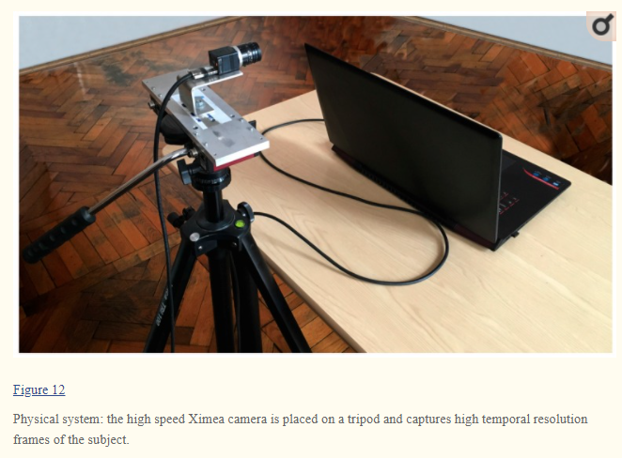**

**3.1 Outline of Micro Emotion Detection and Classification**

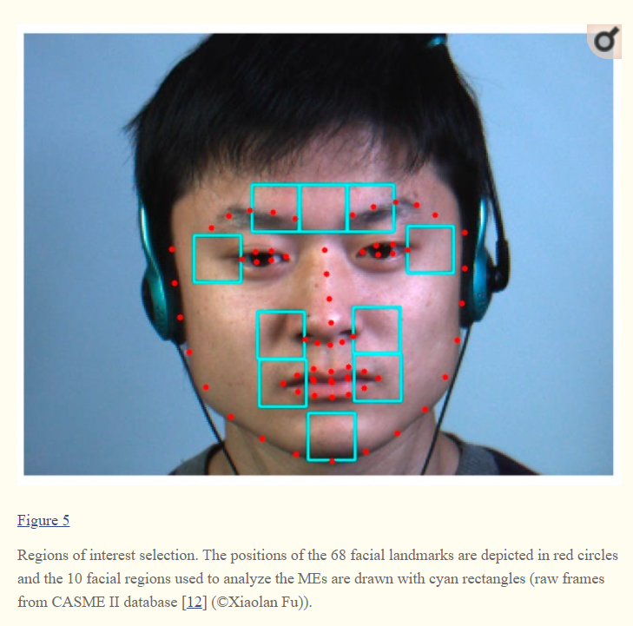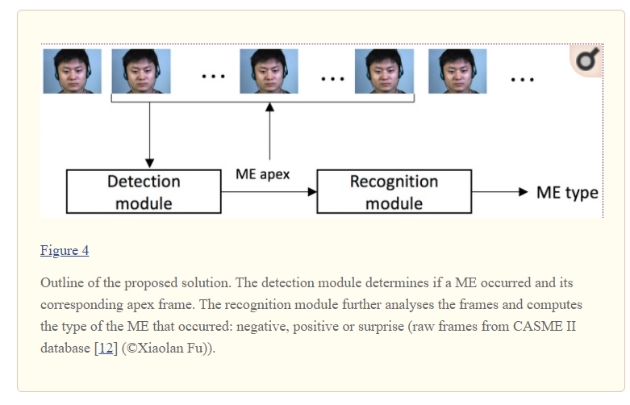We have used a framework for ME detection and recognition based on simple motion descriptors.

The framework takes as input full video clips and computes the apex positions as well as the types of the MEs that occurred. First, the detection module determines the moment (the apex frame) when a ME occurred based on the motion magnitude variation across the video frames. The detected apex locations are fed to the recognition module, which uses only the frames around the apex position to determine the type of the ME (positive, negative or surprise).

3.2. Facial Landmarks Detection and Cell Selection

A general off the shelf facial landmark detector [[23](https://www.ncbi.nlm.nih.gov/pmc/articles/PMC5751645/#B23-sensors-17-02913),[24](https://www.ncbi.nlm.nih.gov/pmc/articles/PMC5751645/#B24-sensors-17-02913)] is used to detect 68 landmarks on the face. Based on the position of these landmarks, we defined 10 regions on the face that roughly correspond to the position of the muscles of facial expressions, as shown in [Figure 5](https://www.ncbi.nlm.nih.gov/pmc/articles/PMC5751645/figure/sensors-17-02913-f005/).

The three upper cells correspond to the left frontalis, procerus and right frontalis muscles, respectively. The two cells around the eyes overlap the orbicularis oculi muscles. The four cells around the nostrils and mouth area are related to the orbicularis oris and zygomatics muscles. Finally, the cell in the chin area corresponds to the mentalis muscle [[25](https://www.ncbi.nlm.nih.gov/pmc/articles/PMC5751645/#B25-sensors-17-02913)]. The width of a cell was heuristically set to half the mouth width.

Based on the orientation determined by the off-the-shelf detector, we correct the small face orientations with normalization; more specifically, the face is rotated such that the roll angle becomes 0.

### 3.3. Micro-Expression Detection

The detection module relies on the magnitude of the movement that occurs across the high-speed video frames computed by simple absolute image differences. The motion information is extracted from each frame and Adaboost [[26](https://www.ncbi.nlm.nih.gov/pmc/articles/PMC5751645/#B26-sensors-17-02913),[27](https://www.ncbi.nlm.nih.gov/pmc/articles/PMC5751645/#B27-sensors-17-02913)] algorithm is used to decide if a frame belongs to the ME or the non-ME class. The outline of the detection module is depicted in [Figure 6](https://www.ncbi.nlm.nih.gov/pmc/articles/PMC5751645/figure/sensors-17-02913-f006/).

**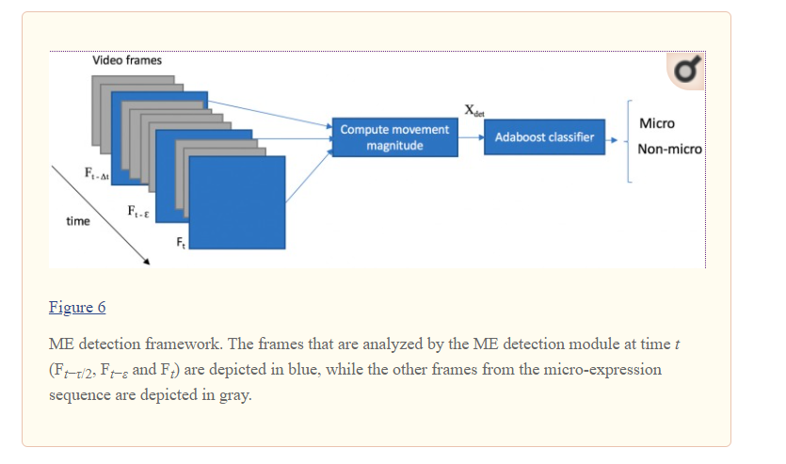**

Classifying to micro emotion categories

Face detection

Feature extraction

Take the face point co- ordinates using Open pose

Filtering frames required to detect micro emotions

Identify face

Feature Extraction

**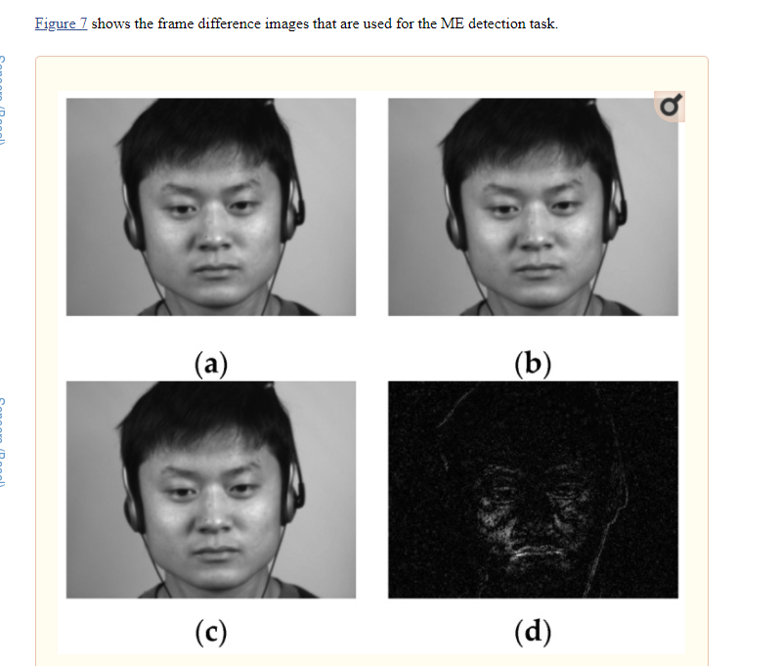**

### .4. Micro-Expression Recognition

**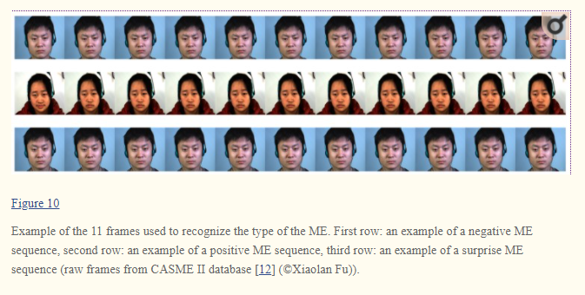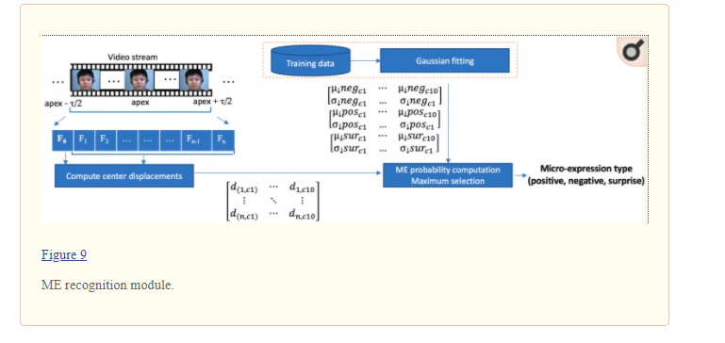**The flow of the ME recognition module is depicted in [Figure 9](https://www.ncbi.nlm.nih.gov/pmc/articles/PMC5751645/figure/sensors-17-02913-f009/). The features used to recognize the ME type is the relative center displacement of the movement magnitude image within each facial cell. During the training phase, a 2D Gaussian is fit to the data for each ME type (positive, negative and surprise). For the test phase, to decide the type of a new ME sequence, we simply compute and multiply the probabilities of the cell movements to belong to the ME classes.

## **References**

1. Haggard E.A., Isaacs K.S. Methods of Research in Psychotherapy. Springer; Boston, MA, USA: 1966. Micromomentary facial expressions as indicators of ego mechanisms in psychotherapy; pp. 154–165. [[Google Scholar](https://scholar.google.com/scholar_lookup?title=Methods+of+Research+in+Psychotherapy&author=E.A.+Haggard&author=K.S.+Isaacs&publication_year=1966&)]

2. Ekman P. Telling Lies: Clues to Deceit in the Marketplace, Politics, and Marriage. revised ed. WW Norton & Company; New York, NY, USA: 2009. [[Google Scholar](https://scholar.google.com/scholar_lookup?title=Telling+Lies:+Clues+to+Deceit+in+the+Marketplace,+Politics,+and+Marriage&author=P.+Ekman&publication_year=2009&)]

3. Ekman P., Rosenberg E.L. What the Face Reveals: Basic and Applied Studies of Spontaneous Expression Using the Facial Action Coding System (FACS) Oxford University Press; New York, NY, USA: 1997. [[Google Scholar](https://scholar.google.com/scholar_lookup?title=What+the+Face+Reveals:+Basic+and+Applied+Studies+of+Spontaneous+Expression+Using+the+Facial+Action+Coding+System+(FACS)&author=P.+Ekman&author=E.L.+Rosenberg&publication_year=1997&)]

4. Center for Body Language The Micro Expression Test. [(accessed on 30 September 2017)]; Available online: <http://www.microexpressionstest.com/micro-expressions-test/>

5. Nelson N.L., Russell J.A. Universality revisited. Emot. Rev. 2013;5:8–15. doi: 10.1177/1754073912457227. [[CrossRef](https://dx.doi.org/10.1177%2F1754073912457227" \t "pmc_ext)] [[Google Scholar](https://scholar.google.com/scholar_lookup?journal=Emot.+Rev.&title=Universality+revisited&author=N.L.+Nelson&author=J.A.+Russell&volume=5&publication_year=2013&pages=8-15&doi=10.1177/1754073912457227&)]

6. Bettadapura V. Face expression recognition and analysis: The state of the art. arXiv. 20121203.6722 [[Google Scholar](https://scholar.google.com/scholar_lookup?journal=arXiv&title=Face+expression+recognition+and+analysis:+The+state+of+the+art&author=V.+Bettadapura&publication_year=2012&)]

7. Polikovsky S., Kameda Y., Ohta Y. Facial micro-expression detection in hi-speed video based on facial action coding system (FACS) IEICE Trans. Inf. Syst. 2013;96:81–92. doi: 10.1587/transinf.E96.D.81. [[CrossRef](https://dx.doi.org/10.1587%2Ftransinf.E96.D.81" \t "pmc_ext)] [[Google Scholar](https://scholar.google.com/scholar_lookup?journal=IEICE+Trans.+Inf.+Syst.&title=Facial+micro-expression+detection+in+hi-speed+video+based+on+facial+action+coding+system+(FACS)&author=S.+Polikovsky&author=Y.+Kameda&author=Y.+Ohta&volume=96&publication_year=2013&pages=81-92&doi=10.1587/transinf.E96.D.81&)]

8. Porter S., Ten Brinke L. Reading between the lies: Identifying concealed and falsified emotions in universal facial expressions. Psychol. Sci. 2008;19:508–514. doi: 10.1111/j.1467-9280.2008.02116.x. [[PubMed](https://www.ncbi.nlm.nih.gov/pubmed/18466413)] [[CrossRef](https://dx.doi.org/10.1111%2Fj.1467-9280.2008.02116.x" \t "pmc_ext)] [[Google Scholar](https://scholar.google.com/scholar_lookup?journal=Psychol.+Sci.&title=Reading+between+the+lies:+Identifying+concealed+and+falsified+emotions+in+universal+facial+expressions&author=S.+Porter&author=L.+Ten+Brinke&volume=19&publication_year=2008&pages=508-514&pmid=18466413&doi=10.1111/j.1467-9280.2008.02116.x&)]

9. Pfister T., Li X., Zhao G., Pietikäinen M. Recognising spontaneous facial micro-expressions; Proceedings of the 2011 IEEE International Conference on Computer Vision (ICCV); Barcelona, Spain. 6–13 November 2011; pp. 1449–1456. [[Google Scholar](https://scholar.google.com/scholar_lookup?journal=Proceedings+of+the+2011+IEEE+International+Conference+on+Computer+Vision+(ICCV)&title=Recognising+spontaneous+facial+micro-expressions&author=T.+Pfister&author=X.+Li&author=G.+Zhao&author=M.+Pietik%C3%A4inen&pages=1449-1456&)]

10. Li X., Pfister T., Huang X., Zhao G., Pietikäinen M. A spontaneous micro-expression database: Inducement, collection and baseline; Proceedings of the 2013 10th IEEE International Conference and Workshops on Automatic Face and Gesture Recognition (FG); Shanghai, China. 22–26 April 2013; pp. 1–6. [[Google Scholar](https://scholar.google.com/scholar_lookup?journal=Proceedings+of+the+2013+10th+IEEE+International+Conference+and+Workshops+on+Automatic+Face+and+Gesture+Recognition+(FG)&title=A+spontaneous+micro-expression+database:+Inducement,+collection+and+baseline&author=X.+Li&author=T.+Pfister&author=X.+Huang&author=G.+Zhao&author=M.+Pietik%C3%A4inen&pages=1-6&)]

11. Yan W.J., Wu Q., Liu Y.J., Wang S.J., Fu X. CASME database: A dataset of spontaneous micro-expressions collected from neutralized faces; Proceedings of the 2013 10th IEEE International Conference and Workshops on Automatic Face and Gesture Recognition (FG); Shanghai, China. 22–26 April 2013; pp. 1–7. [[Google Scholar](https://scholar.google.com/scholar_lookup?journal=Proceedings+of+the+2013+10th+IEEE+International+Conference+and+Workshops+on+Automatic+Face+and+Gesture+Recognition+(FG)&title=CASME+database:+A+dataset+of+spontaneous+micro-expressions+collected+from+neutralized+faces&author=W.J.+Yan&author=Q.+Wu&author=Y.J.+Liu&author=S.J.+Wang&author=X.+Fu&pages=1-7&)]

12. Yan W.J., Li X., Wang S.J., Zhao G., Liu Y.J., Chen Y.H., Fu X. CASME II: An improved spontaneous micro-expression database and the baseline evaluation. PLoS ONE. 2014;9:e86041. doi: 10.1371/journal.pone.0086041. [[PMC free article](https://www.ncbi.nlm.nih.gov/pmc/articles/PMC3903513/)] [[PubMed](https://www.ncbi.nlm.nih.gov/pubmed/24475068)] [[CrossRef](https://dx.doi.org/10.1371%2Fjournal.pone.0086041" \t "pmc_ext)] [[Google Scholar](https://scholar.google.com/scholar_lookup?journal=PLoS+ONE&title=CASME+II:+An+improved+spontaneous+micro-expression+database+and+the+baseline+evaluation&author=W.J.+Yan&author=X.+Li&author=S.J.+Wang&author=G.+Zhao&author=Y.J.+Liu&volume=9&publication_year=2014&pages=e86041&pmid=24475068&doi=10.1371/journal.pone.0086041&)]

13. Ofodile I., Kulkarni K., Corneanu C.A., Escalera S., Baro X., Hyniewska S., Allik J., Anbarjafari G. Automatic recognition of deceptive facial expressions of emotion. arXiv. 20171707.04061 [[Google Scholar](https://scholar.google.com/scholar_lookup?journal=arXiv&title=Automatic+recognition+of+deceptive+facial+expressions+of+emotion&author=I.+Ofodile&author=K.+Kulkarni&author=C.A.+Corneanu&author=S.+Escalera&author=X.+Baro&publication_year=2017&)]

14. Liong S.T., See J., Phan R.C.W., Le Ngo A.C., Oh Y.H., Wong K. Asian Conference on Computer Vision. Springer; Cham, Switzerland: 2014. Subtle expression recognition using optical strain weighted features; pp. 644–657. [[Google Scholar](https://scholar.google.com/scholar_lookup?title=Asian+Conference+on+Computer+Vision&author=S.T.+Liong&author=J.+See&author=R.C.W.+Phan&author=A.C.+Le+Ngo&author=Y.H.+Oh&publication_year=2014&)]

15. Liong S.T., See J., Phan R.C.-W., Oh Y.H., Le Ngo A.C., Wong K., Tan S.W. Spontaneous subtle expression detection and recognition based on facial strain. Signal. Process. Image. 2016;47:170–182. doi: 10.1016/j.image.2016.06.004. [[CrossRef](https://dx.doi.org/10.1016%2Fj.image.2016.06.004" \t "pmc_ext)] [[Google Scholar](https://scholar.google.com/scholar_lookup?journal=Signal.+Process.+Image&title=Spontaneous+subtle+expression+detection+and+recognition+based+on+facial+strain&author=S.T.+Liong&author=J.+See&author=R.C.-W.+Phan&author=Y.H.+Oh&author=A.C.+Le+Ngo&volume=47&publication_year=2016&pages=170-182&doi=10.1016/j.image.2016.06.004&)]

16. Polikovsky S., Kameda Y., Ohta Y. Facial micro-expressions recognition using high speed camera and 3D-gradient descriptor; Proceedings of the 3rd International Conference on Imaging for crime Detection and Prevention; London, UK. 3 December 2009. [[Google Scholar](https://scholar.google.com/scholar_lookup?journal=Proceedings+of+the+3rd+International+Conference+on+Imaging+for+crime+Detection+and+Prevention&title=Facial+micro-expressions+recognition+using+high+speed+camera+and+3D-gradient+descriptor&author=S.+Polikovsky&author=Y.+Kameda&author=Y.+Ohta&)]

17. Li X., Hong X., Moilanen A., Huang X., Pfister T., Zhao G., Pietikainen M. Towards Reading Hidden Emotions: A Comparative Study of Spontaneous Micro-expression Spotting and Recognition Methods. IEEE Trans. Affect. Comput. 2017;99:1. doi: 10.1109/TAFFC.2017.2667642. [[CrossRef](https://dx.doi.org/10.1109%2FTAFFC.2017.2667642" \t "pmc_ext)] [[Google Scholar](https://scholar.google.com/scholar_lookup?journal=IEEE+Trans.+Affect.+Comput.&title=Towards+Reading+Hidden+Emotions:+A+Comparative+Study+of+Spontaneous+Micro-expression+Spotting+and+Recognition+Methods&author=X.+Li&author=X.+Hong&author=A.+Moilanen&author=X.+Huang&author=T.+Pfister&volume=99&publication_year=2017&pages=1&doi=10.1109/TAFFC.2017.2667642&)]

18. Wu H.Y., Rubinstein M., Shih E., Guttag J., Durand F., Freeman W. Eulerian video magnification for revealing subtle changes in the world. ACM Trans. Graph. 2012;31:1–8. doi: 10.1145/2185520.2185561. [[CrossRef](https://dx.doi.org/10.1145%2F2185520.2185561" \t "pmc_ext)] [[Google Scholar](https://scholar.google.com/scholar_lookup?journal=ACM+Trans.+Graph.&title=Eulerian+video+magnification+for+revealing+subtle+changes+in+the+world&author=H.Y.+Wu&author=M.+Rubinstein&author=E.+Shih&author=J.+Guttag&author=F.+Durand&volume=31&publication_year=2012&pages=1-8&doi=10.1145/2185520.2185561&)]

19. Li X., Yu J., Zhan S. Spontaneous facial micro-expression detection based on deep learning; Proceedings of the 2016 IEEE 13th International Conference on Signal Processing (ICSP); Chengdu, China. 6–10 November 2016; pp. 1130–1134. [[Google Scholar](https://scholar.google.com/scholar_lookup?journal=Proceedings+of+the+2016+IEEE+13th+International+Conference+on+Signal+Processing+(ICSP)&title=Spontaneous+facial+micro-expression+detection+based+on+deep+learning&author=X.+Li&author=J.+Yu&author=S.+Zhan&pages=1130-1134&)]

20. Breuer R., Kimmel R.A. Deep Learning Perspective on the Origin of Facial Expressions. arXiv. 20171705.01842 [[Google Scholar](https://scholar.google.com/scholar_lookup?journal=arXiv&title=Deep+Learning+Perspective+on+the+Origin+of+Facial+Expressions&author=R.+Breuer&author=R.A.+Kimmel&publication_year=2017&)]

21. Cox M., Nuevo-Chiquero J., Saragih J., Lucey S. Brisbane, Australia: 2013. [(accessed on 25 October 2017)]. CSIRO Face Analysis SDK. Available online: <http://face.ci2cv.net/> [[Google Scholar](https://scholar.google.com/scholar?q=Cox+M.+Nuevo-Chiquero+J.+Saragih+J.+Lucey+S.+CSIRO+Face+Analysis+SDK+Brisbane,+Australia+2013+Available+online:++http://face.ci2cv.net/+(accessed+on+25+October+2017)+)]

22. Saragih J.M., Lucey S., Cohn J.F. Deformable model fitting by regularized landmark mean-shift. Int. J. Comput. Vis. 2011;91:200–215. doi: 10.1007/s11263-010-0380-4. [[CrossRef](https://dx.doi.org/10.1007%2Fs11263-010-0380-4" \t "pmc_ext)] [[Google Scholar](https://scholar.google.com/scholar_lookup?journal=Int.+J.+Comput.+Vis.&title=Deformable+model+fitting+by+regularized+landmark+mean-shift&author=J.M.+Saragih&author=S.+Lucey&author=J.F.+Cohn&volume=91&publication_year=2011&pages=200-215&doi=10.1007/s11263-010-0380-4&)]

23. Hiatt J.L., Gartner L.P. Textbook of Head and Neck Anatomy. 4th ed. LWW; Philadelphia, PA, USA: 2009. [[Google Scholar](https://scholar.google.com/scholar_lookup?title=Textbook+of+Head+and+Neck+Anatomy&author=J.L.+Hiatt&author=L.P.+Gartner&publication_year=2009&)]

24. Freund Y., Schapire R.E. European Conference on Computational Learning Theory. Springer; Berlin/Heideberg, Germany: 1995. A decision-theoretic generalization of on-line learning and an application to boosting; pp. 23–37. [[Google Scholar](https://scholar.google.com/scholar_lookup?title=European+Conference+on+Computational+Learning+Theory&author=Y.+Freund&author=R.E.+Schapire&publication_year=1995&)]

25. Zhu J., Zou H., Rosset S., Hastie T. Multi-class adaboost. Stat. Its Interface. 2009;2:349–360. [[Google Scholar](https://scholar.google.com/scholar_lookup?journal=Stat.+Its+Interface&title=Multi-class+adaboost&author=J.+Zhu&author=H.+Zou&author=S.+Rosset&author=T.+Hastie&volume=2&publication_year=2009&pages=349-360&)]

26. Ekman P., Friesen W.V. Constants across cultures in the face and emotion. J. Pers. Soc. Psychol. 1971;17:124. doi: 10.1037/h0030377. [[PubMed](https://www.ncbi.nlm.nih.gov/pubmed/5542557)] [[CrossRef](https://dx.doi.org/10.1037%2Fh0030377" \t "pmc_ext)] [[Google Scholar](https://scholar.google.com/scholar_lookup?journal=J.+Pers.+Soc.+Psychol.&title=Constants+across+cultures+in+the+face+and+emotion&author=P.+Ekman&author=W.V.+Friesen&volume=17&publication_year=1971&pages=124&pmid=5542557&doi=10.1037/h0030377&)]

27. Shen X.-B., Wu Q., Fu X.-L. Effects of the duration of expressions on the recognition of microexpressions. J. Zhejiang Univ. Sci. B. 2012;13:221–230. doi: 10.1631/jzus.B1100063. [[PMC free article](https://www.ncbi.nlm.nih.gov/pmc/articles/PMC3296074/)] [[PubMed](https://www.ncbi.nlm.nih.gov/pubmed/22374615)] [[CrossRef](https://dx.doi.org/10.1631%2Fjzus.B1100063" \t "pmc_ext)] [[Google Scholar](https://scholar.google.com/scholar_lookup?journal=J.+Zhejiang+Univ.+Sci.+B&title=Effects+of+the+duration+of+expressions+on+the+recognition+of+microexpressions&author=X.-B.+Shen&author=Q.+Wu&author=X.-L.+Fu&volume=13&publication_year=2012&pages=221-230&pmid=22374615&doi=10.1631/jzus.B1100063&)]

28. Wikipedia, Screening of Passengers by Observation Techniques: (SPOT—TSA program) [(accessed on 8 October 2017)]; Available online: <https://en.wikipedia.org/wiki/SPOT_(TSA_program)>

29. Andelin E.I., Rusu A.S. Investigation of Facial Micro-expressions of Emotions in Psychopathy—A Case Study of an Individual in Detention. Procedia Soc. Behav. Sci. 2015;209:46–52. doi: 10.1016/j.sbspro.2015.11.230. [[CrossRef](https://dx.doi.org/10.1016%2Fj.sbspro.2015.11.230" \t "pmc_ext)] [[Google Scholar](https://scholar.google.com/scholar_lookup?journal=Procedia+Soc.+Behav.+Sci.&title=Investigation+of+Facial+Micro-expressions+of+Emotions+in+Psychopathy%E2%80%94A+Case+Study+of+an+Individual+in+Detention&author=E.I.+Andelin&author=A.S.+Rusu&volume=209&publication_year=2015&pages=46-52&doi=10.1016/j.sbspro.2015.11.230&)]

30. Viola P., Jones M.J. Robust real-time face detection. Int. J. Comput. Vis. 2004;57:137–154. doi: 10.1023/B:VISI.0000013087.49260.fb. [[CrossRef](https://dx.doi.org/10.1023%2FB%3AVISI.0000013087.49260.fb" \t "pmc_ext)] [[Google Scholar](https://scholar.google.com/scholar_lookup?journal=Int.+J.+Comput.+Vis.&title=Robust+real-time+face+detection&author=P.+Viola&author=M.J.+Jones&volume=57&publication_year=2004&pages=137-154&doi=10.1023/B:VISI.0000013087.49260.fb&)]

31. Ximea Cameras Homepage. [(accessed on 20 October 2017)]; Available online: <https://www.ximea.com/>